- IFS

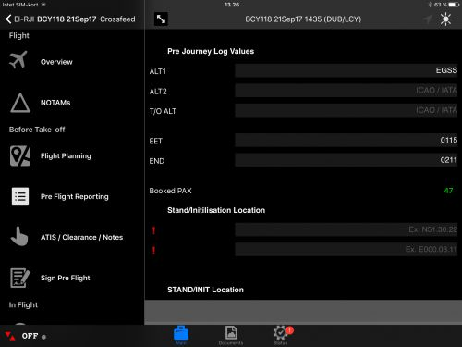
- Document Management & Library Module
- Voyage/Journey Log Module
- provides import of Flight Briefing information, weather, notams
- ATC & ATIS Note Taker Module
- eLoadsheet Module
- Take-Off Performance Integration Module
- eTechlog Module
- eReporting Module
- Web-based OCC Overview

The Back-Office portal engine can also import and export all incoming
flight data directly to your servers in parallel as well take care of all data
import from your back-end system solutions into the EFB system. Flight
data recordings will be exported into your Back-end systems instantly they
arrive as signed flights from the crew.

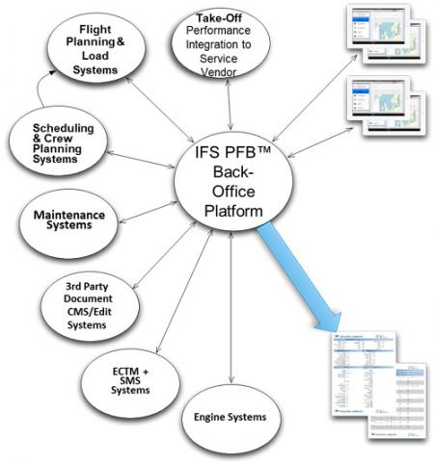

- ASQS (Safety and Quality solutions)

- ICAO Doc. 9859
- ICAO Annex 19
- EASA
- IOSA

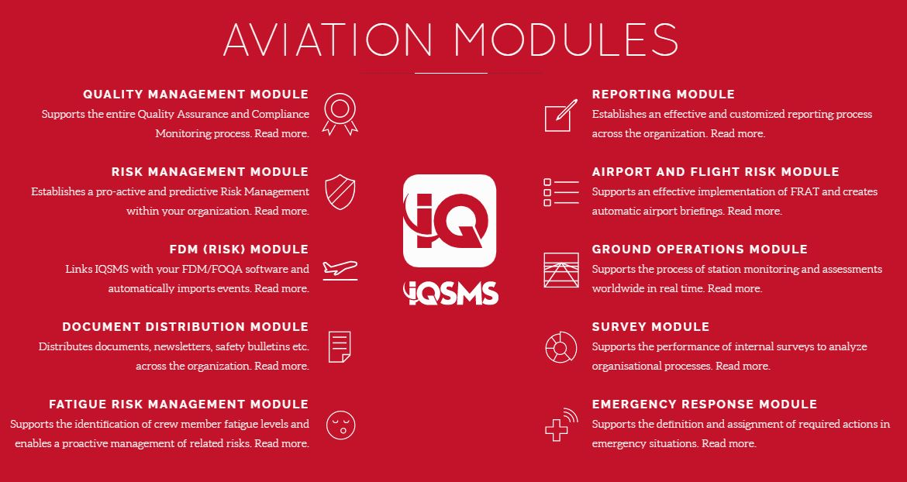

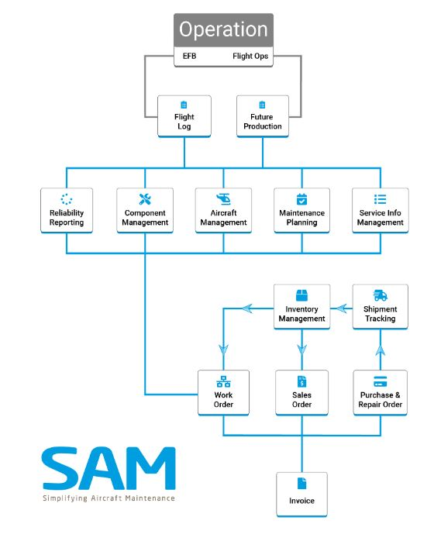
- ASA (Simple Aircraft Maintenance)

- Less staff to manage Aircrafts
- Fleet Status is easily accessible
- Efficient workflow from quotation to invoice
- Minimize aircraft ground time by accelerating operations
- Paperless environment
- Fast and easy aircraft profile build
- Analyzing and engineering work order
- Provide fast & easy overview of the spare part situation.
- Provides full cost overview of project.

- MCCPILOTLOG

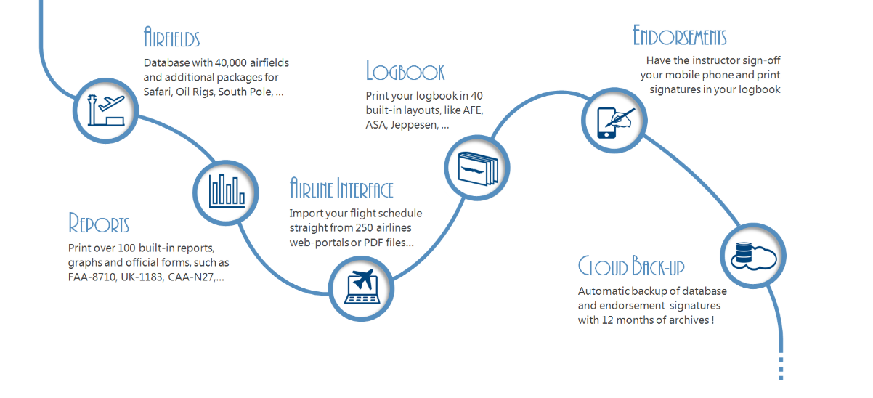

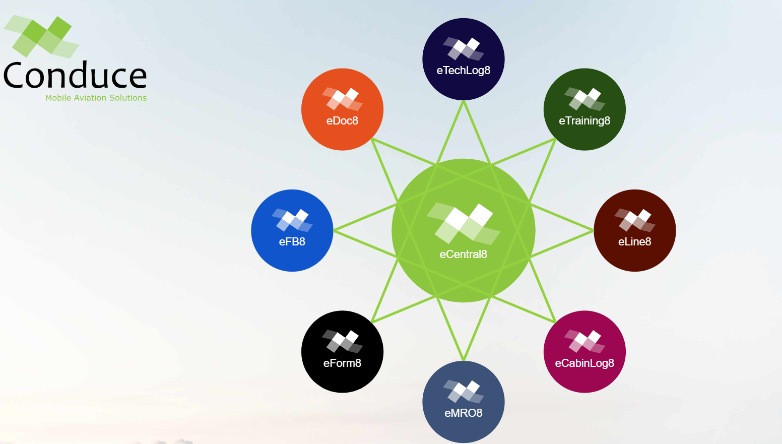

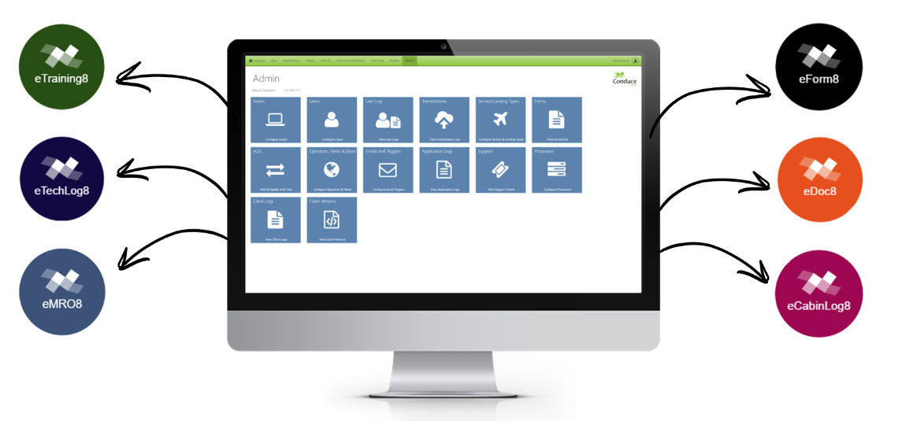

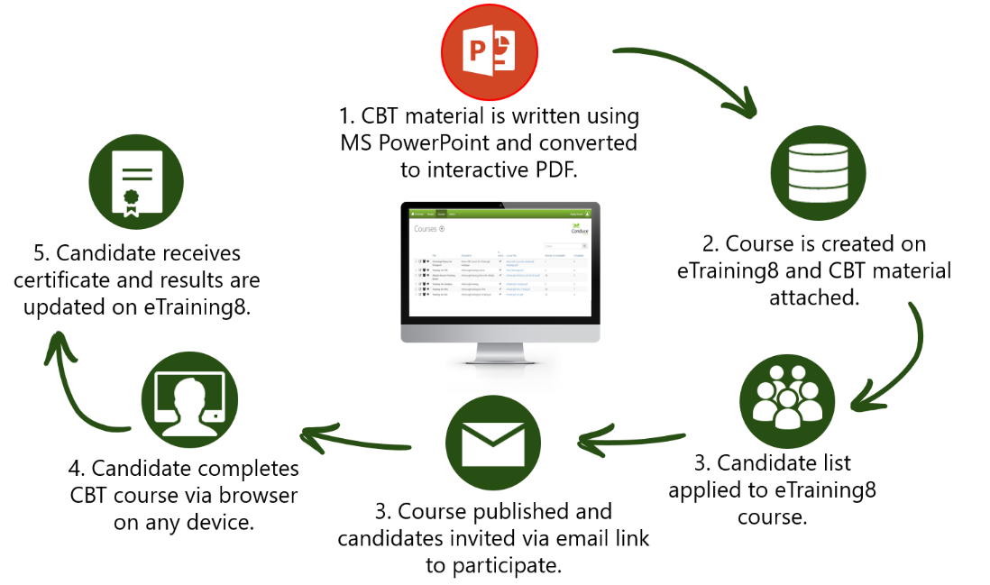
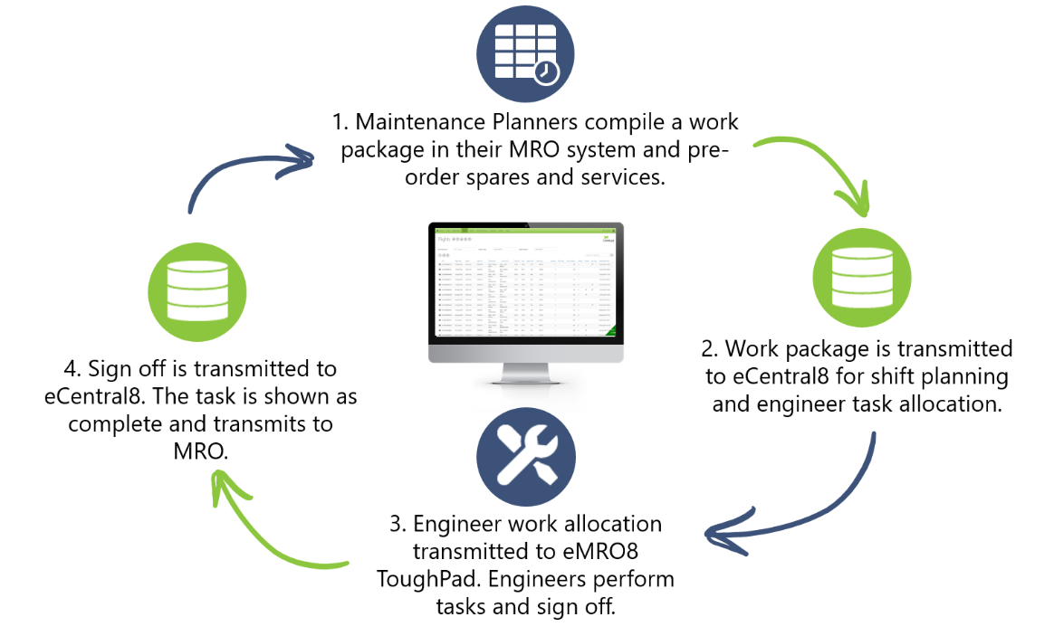
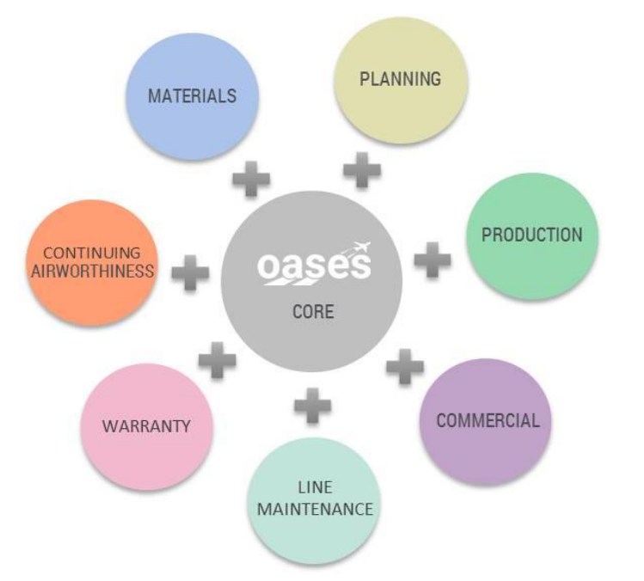


  AIRPORT DATABASE PROVIDER  PERFORMANCE SOFTWARE  LOADSHEET SOFTWARE  NOTAM FILTERING |   Sales  Crew  OPS  Maintenance  Reporting |   FLIGHT OPTIMIZATION & ROUTE CHALLENGING  TAKE-OFF & LANDING REPORT (TLR)  Flight Plan
  Flight Planning  ICAO Flight Plan Filing  Weather  NOTAMs  Runway Performance  Flight Tracking |   EFB System  CLOSE THE ELECTRONIC GAP BETWEEN PRE- & POST-FLIGHT |   Logbook Solutions
  RUNWAY ANALYSIS  WEIGHT & BALANCE  ONE ENGINE INOP PROCEDURES  EFB |   Crew Management  Flight Operation  Slot Management  Training  Crew Tracking |   Flight Tracking  Health Monitoring  FDR Streaming  Fuel Managemnt

